79th Annual Regatta One-Design Notice of Race
CORSICA RIVER YACHT CLUB 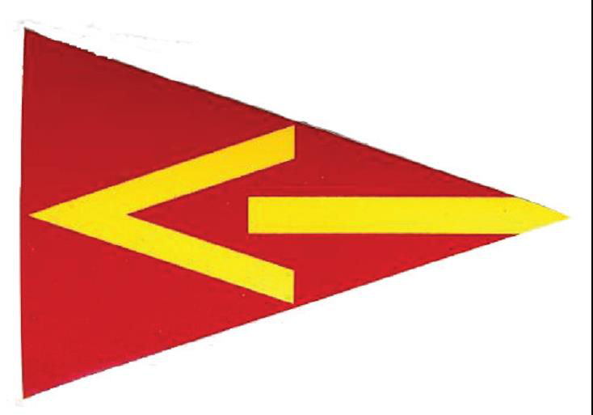
589 Conquest Road, Centreville, MD, 21617.

Saturday 24 July 2021 Sunday 25 July 2021
Entry on site: Saturday 24July 2021 from 0900-1000. Entry Fee: $40
Online Entry: Check the CRYC web site at www.cryc.org or Regetta Network for online entry. On line entries close 6:00 PM Friday
Contact: Art Silcox 571-213-9536, art.silcox@gmail.com
Eligible: Laser, Laser Radial, Comet, Windmill, Hampton, Albacore, Penguin, Catboats, Hobie Wave, A-Cat
Four boat minimum for start
Rendezvous: Onshore at Corsica River Sailing Center.
Start: Between flag on Race Committee boat and mark representing the start pin. See Event Sailing Instructions for more detail at www.cryc.org. Sequence will be set on each day of racing.
Signals: RRS Rule 26 (Starting Races) applies.
Saturday - 0930 Skippers Meeting; 1000 Harbor Gun; 1100 1st Warning;
Sunday - 1000 Harbor Gun, 1100 1st warning.
No starts after 1500 Saturday, 1400 Sunday
Course: Drop mark type courses or as designated by letters displayed on Race Committee boat. Two or three racing areas may be used each using different style marks. Marks will be consistent within the racing areas. Government marks will be used for Catboats and A-Cats.
Finish: Between flag on Race Committee boat and mark representing the finish pin.
Rules: This regatta will be governed by The Racing Rules of Sailing 2021-2024 (RRS). RRS 63.7, Conflict between Rules, is replaced by, "If there is a conflict between the Event Sailing Instructions and the Notice of Race, the Event Sailing Instructions shall apply." Notice(s) Of Change will be posted on site before the racing begins.
Awards: Awards given 2 hours after completion of races on Sunday 25 July 2021. (Awards for one day racers Saturday night)
Social: Dinner following Saturday races at Corsica River Sailing Center. We offer Classic Eastern Shore Dinner at 1800 Saturday along with live Blue Grass music. For details about dinner reservations and menu, please visit www.cryc.org. Reservations due no later than 1800 Friday 23 July.
Picnic after racing Sunday.

Other: Campers can stay free in the site.

