The Classic Wooden Sailboat Race
In conjunction with the NSHOF Classic Wooden Sailboat Rendezvous
18 September 2011
Annapolis, Maryland

NOTICE OF RACE

1 RULES
1.1 The regatta will be governed by the rules as defined in The Racing Rules of Sailing.
1.2 Racing rule 26 will be changed as follows: The start will be a “pursuit-style” start with the slowest boats starting first. The rule changes and start times for each boat will appear in full in the Sailing Instructions. The Sailing Instructions may also change other racing rules.
2 ELIGIBILITY AND ENTRY
2.1 The regatta is open to sailing yachts with an overall length less than 60 feet, designed before 1970 whose hull is built of wood. Vessels designed after 1970 who wish to enter will be reviewed on a case-by-case basis.
2.2 Eligible boats may enter by completing the attached form and sending it, together with the required fee, to Classic Yacht Race, National Sailing Hall of Fame, 67-69 Prince George Street, Annapolis, MD 21401. Entries must be received by 11 September 2011.
3 SCHEDULE
3.1 Registration: at the National Sailing Hall of Fame dock on17 September 2011, from 1700 To 1800.
3.2 The scheduled time of the warning signal for the first start is 1100.
4 MEASUREMENTS
Boats shall be rated and scored using the Portsmouth Yardstick Handicapping System as modified for classic boats. Entries without established ratings shall be given a temporary rating by the Handicapping Committee. Assigned ratings may not be appealed. Boats will be placed in either the Dayboats or Cruising Class depending on their design features.
5 SAILING INSTRUCTIONS
The sailing instructions will be available by 1700 on 17 September at the National Sailing Hall of Fame dock.
6 THE COURSE
The diagram below shows the course area. The approximate course length will be 4.5 NM (three laps). The course may be shortened to one or two laps (three laps is shown). The Sailing Instructions will include a full description of the course.
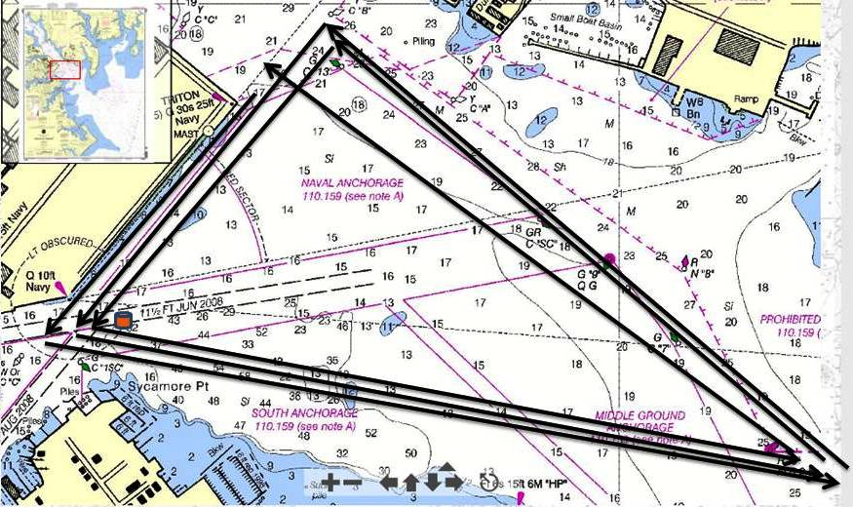
7 Decisions of the protest committee will be final as provided in rule 70.5.
8 PRIZES
Prizes will be given as follows: 1st, 2nd and 3rd on corrected time in each class (Dayboats and Cruisers), oldest boat and farthest travelled. Additional prizes may be awarded based on the number of entries.
9 DISCLAIMER OF LIABILITY
Competitors participate in the regatta entirely at their own risk. See rule 4, Decision to Race. The organizing authority will not accept any liability for material damage or personal injury or death sustained in conjunction with or prior to, during, or after the regatta.
10 FURTHER INFORMATION
For further information on the race please contact Paul Miller (Regatta Chair) at dawnpaulmiller@comcast.net or Bill Muesler (Race Chair) at museler@verizon.net.

